**Wind Energy Conversion Systems**

**Assignment 1**

**Muhammad Shamaas**

**ID # 2018-MS-EE-4**

**Introduction**

This case study investigates the dynamic performance of a 2.3 MW, 690 V, 50 Hz, 1512 rpm squirrel-cage induction generator wind energy system during system start-up, and verifies that a large SCIG cannot be directly connected to the grid due to the excessive inrush current and torque oscillations. The shaft of the generator is coupled to the wind turbine through a gearbox. During the system start-up, the turbine and generator are brought by the wind to a certain speed, at which the generator is connected to the grid of 690 V/50 Hz by a switch. The investigation is carried out in two cases: Dynamic Performance of SCIG with Direct Grid Connection and Direct Grid Connection of SCIG with constant Rotor Speed.

The dq-axis model of the induction generator can be obtained by decomposing the voltage, current and flux linkage space-vectors into their corresponding d- and q-axis components.

The αβ stationary reference frame is derived from dq-axis rotating reference frame by putting θ = 0 and . The transformation of three-phase variables in the stationary reference frame into the two-phase variables also in the stationary frame is often referred to as abc/αβ transformation:

Similarly, the two-phase to three-phase transformation in the stationary reference frame, known as αβ/abc transformation, can be performed by:

**Part 1: Dynamic Performance of SCIG with Direct Grid Connection**

The wind turbine is initially in a parking mode with the blades pitched out of the wind. When the wind speed reaches an operative level, the blades are pitched into the wind slightly, and wind turbine and generator start to rotate slowly. When the generator is accelerated close to the rated speed of 1450 rpm (0.959 pu), the circuit breaker is closed and the generator is directly connected to the grid.

SCIG dq-axis Reference Frame Model Equations

1. Flux Linkage Equations:
2. Current Equations
3. Motion and Torque Equations

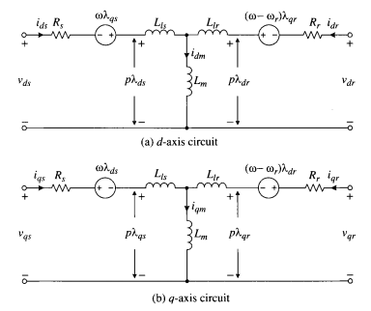

SCIG Machine Constants

1. Rated Line-Line Voltage
2. Rated Stator Current
3. Number of Pole Pairs
4. Rated Stator Frequency
5. Stator Winding Resistance
6. Rotor Winding Resistance
7. Stator Leakage Inductance
8. Rotor Leakage Inductance
9. Magnetizing Inductance
10. Moment of Inertia
11. Rated Rotor Speed
12. Synchronous Speed

Initial Conditions (t = 0-)

In this case, the IG model in the stationary reference frame should be used, which was realized by setting the speed of the arbitrary reference frame to zero (w = 0). The dq-axis rotor voltages are set to zero for simulation of squirrel-cage induction generators.

1. The reference frame is stationary
2. Electrical Frequency
3. Rotor Speed
4. Stator Terminals are open
5. Rotor voltages are zero
6. Electromagnetic Torque is zero

The Rotor is slowly accelerated to a constant speed of by the wind Mechanical Torque . It is assumed that at t = 0-:

1. The rotor is not accelerating
2. Speed Voltages are constant

.

1. Stator and Rotor currents are constant
2. Stator and Rotor flux linkages are constant

.

1. Stator voltages are zero
2. Rotor and Stator Flux Linkages are zero

because

Supply Voltage (t = 0)

The default AC voltage sources in Simulink are Sinusoidal Sources. In order to convert the voltages into cosines, the phase of each voltage is advanced by .

Phase a voltage: Amplitude: , phase angle:

Phase b voltage: Amplitude: , phase angle:

Phase c voltage: Amplitude: , phase angle:

Simulink Model

The input variables of the model include the dq-axis stator voltages vds and vqs, rotor voltages vdr and vqr, the mechanical torque Tm, and the speed of the arbitrary reference frame w. The output variables are dq-axis stator currents, ids and iqs, the electromagnetic torque Te, and the mechanical speed wm of the generator.

1. Block diagram for dynamic simulation of SCIG with direct grid connection.

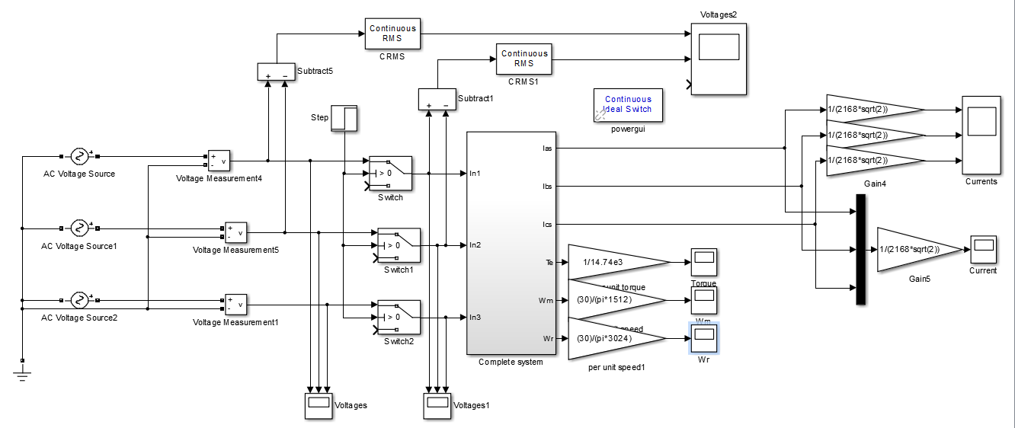

1. SCIG System

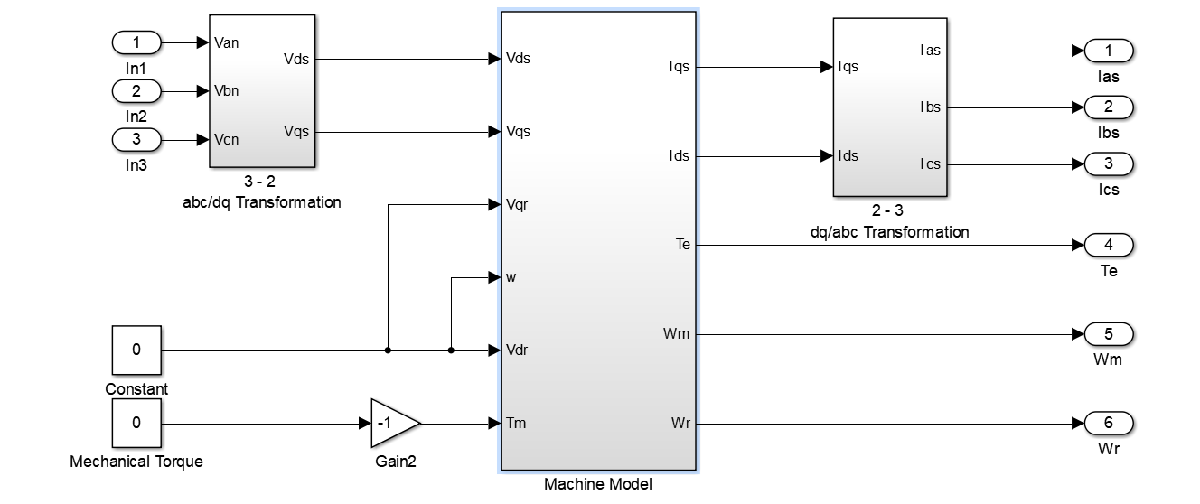

1. Block diagram for dynamic simulation of an induction generator in the arbitrary reference frame

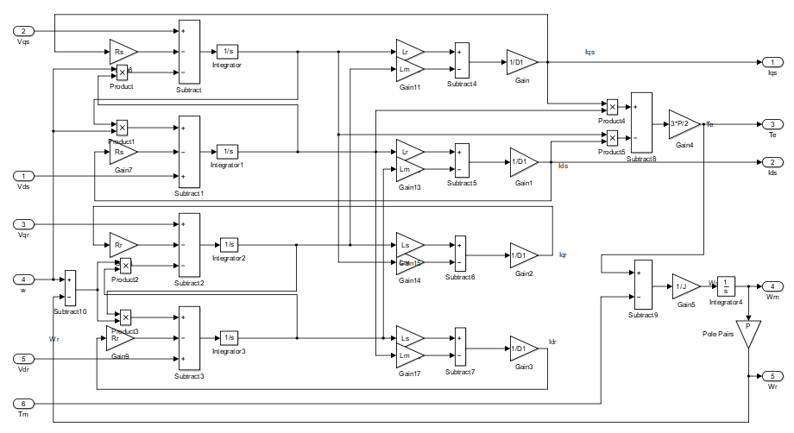

1. Reference Frame Transformations

Assuming a three-phase balanced grid, the grid voltages vas, vbs, and vcs in the stationary frame are transformed to the two-phase voltages vα and vβ in the αβ stationary frame through the abc/αβ transformation. The simulated αβ-axis stator currents ids and iqs are also in the stationary frame, which are transformed to the three-phase currents ias, ibs, and ics by the αβ/abc transformation. The three-phase stator voltages are transformed to the two-phase voltages via the abc/αβ transformation and the calculated two-phase stator currents are transformed back to the three-phase stator currents via the αβ/abc transformation.

abc/αβ Transformation

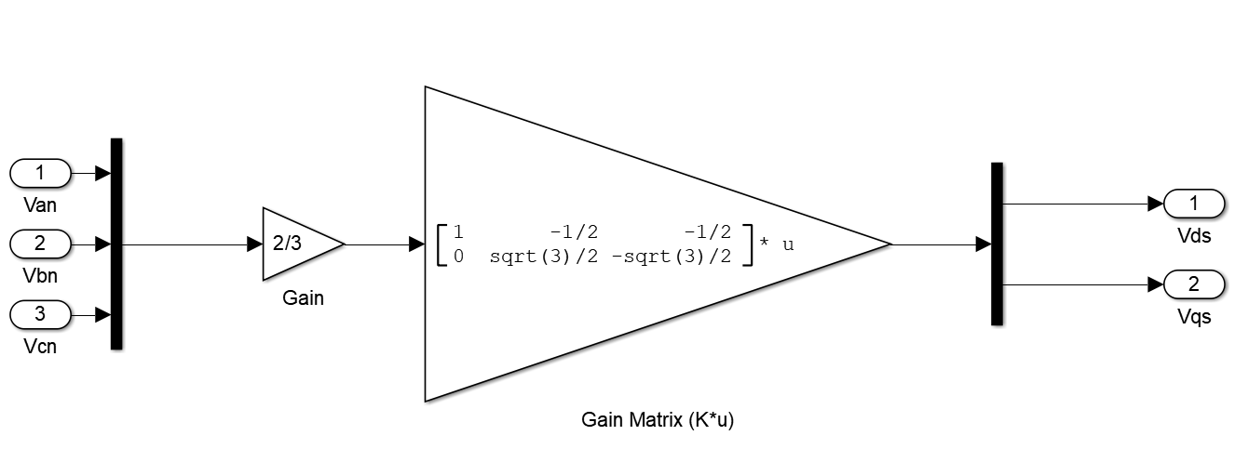

αβ/abc Transformation

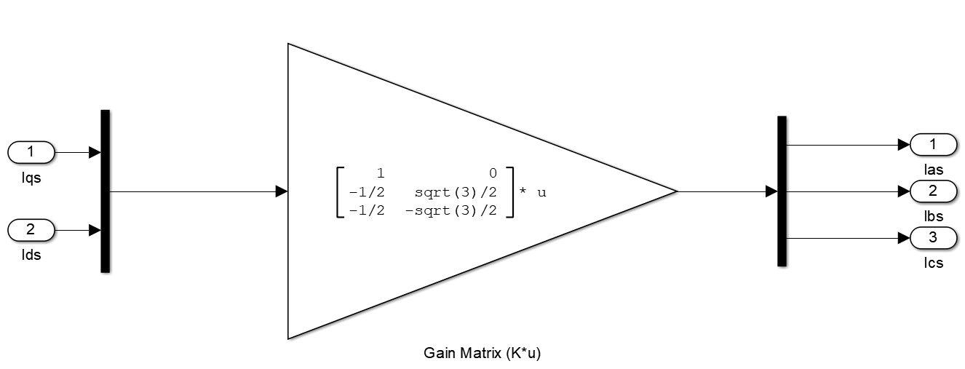

1. WECSConstants.m

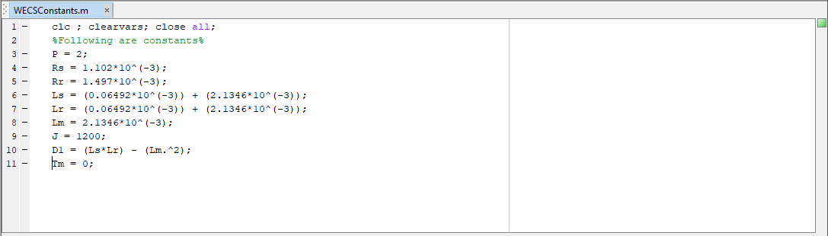

Results

1. Currents (ias, ibs, ics)

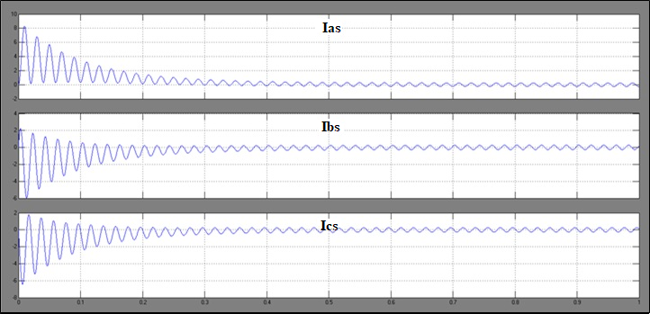

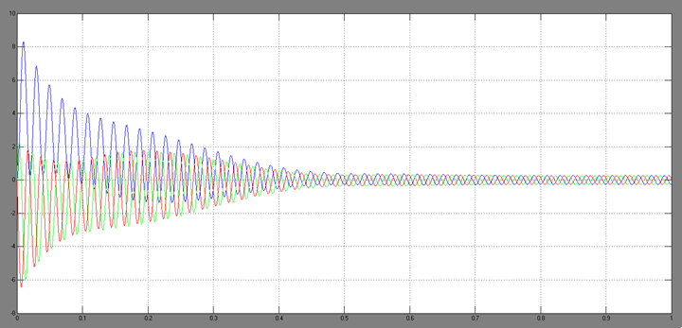

1. Electromagnetic Torque

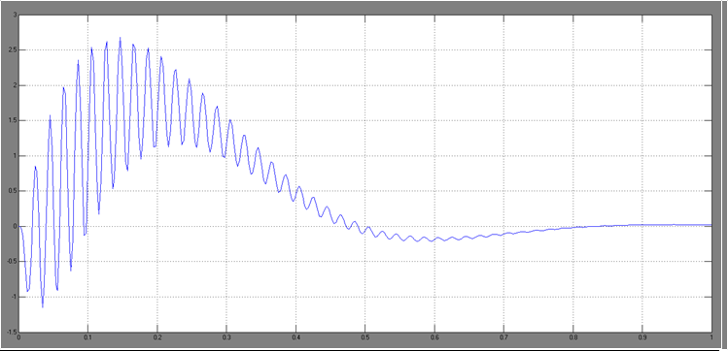

1. Rotor Mechanical Speed

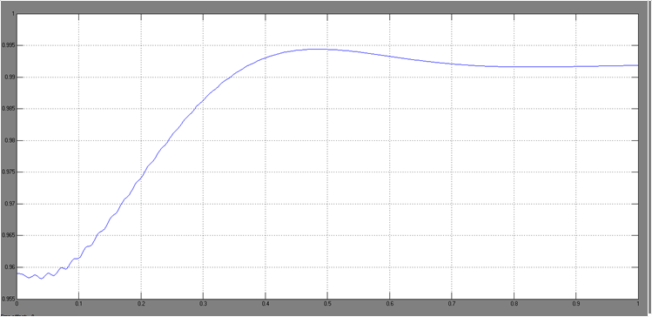

During the system transients, a high inrush current flows into the generator and a DC offset current appears in each of the stator currents ias, ibs, and ics, but the sum of these offset currents is zero due to a three-phase balanced system. As a rotating magnetic field is being built and generator core is being magnetized by the stator current, an electromagnetic torque Te is produced. Since the generator operates below synchronous speed in motoring mode, it produces a positive torque that accelerates the turbine. The generator finally reaches the synchronous speed of 1500 rpm (0.992 pu) at t = 0.84 sec, at which it enters the steady-state operation with Te= Tm = 0. The direct connection of the generator to the grid during the system start-up causes excessive inrush currents with peak values of 8.3 per unit (pu), high electromagnetic torque (2.7 pu, peak), as well as high torque oscillations. It can be concluded that the direct grid connection of the SCIG during the system startup cannot be used in practice, especially for the large megawatt turbines.

**Part 2: Direct Grid Connection of SCIG with constant rotor speed**

The second part of the case study investigates the transients during the direct grid connection of the generator when the speed of the generator is brought by the wind exactly to the synchronous speed of 1500 rpm (0.992 pu). It is assumed that the combined moment of inertia of the generator, gearbox, and blades are very large, such that the rotor speed is kept constant during the electric transients. In this case, the motion equation is simplified to d(wr)/dt = 0 and wr = ωs. The rotor speed wr is then used as one of the system input variables. As a result, the IG simulation block diagram should be slightly modified to accommodate the changes.

Initial Conditions (t = 0-)

In this case, the IG model in the stationary reference frame should be used, which was realized by setting the speed of the arbitrary reference frame to zero (w = 0). The dq-axis rotor voltages are set to zero for simulation of squirrel-cage induction generators.

1. The reference frame is stationary
2. Electrical Frequency
3. Rotor Speed
4. Stator Terminals are open
5. Rotor voltages are zero
6. Electromagnetic Torque is zero

The Rotor is slowly accelerated to a constant speed of by the wind Mechanical Torque . It is assumed that at t = 0-:

1. The rotor is not accelerating
2. Speed Voltages are constant

.

1. Stator and Rotor currents are constant
2. Stator and Rotor flux linkages are constant

.

1. Stator voltages are zero
2. Rotor and Stator Flux Linkages are zero

because

Supply Voltage (t = 0)

The default AC voltage sources in Simulink are Sinusoidal Sources. In order to convert the voltages into cosines, the phase of each voltage is advanced by .

Phase a voltage: Amplitude: , phase angle:

Phase b voltage: Amplitude: , phase angle:

Phase c voltage: Amplitude: , phase angle:

Simulink Model

The input variables of the model include the dq-axis stator voltages vds and vqs, rotor voltages vdr and vqr, the mechanical torque Tm, and the speed of the arbitrary reference frame w. The output variables are dq-axis stator currents, ids and iqs, the electromagnetic torque Te, and the mechanical speed wm of the generator.

1. Block diagram for dynamic simulation of SCIG with direct grid connection.

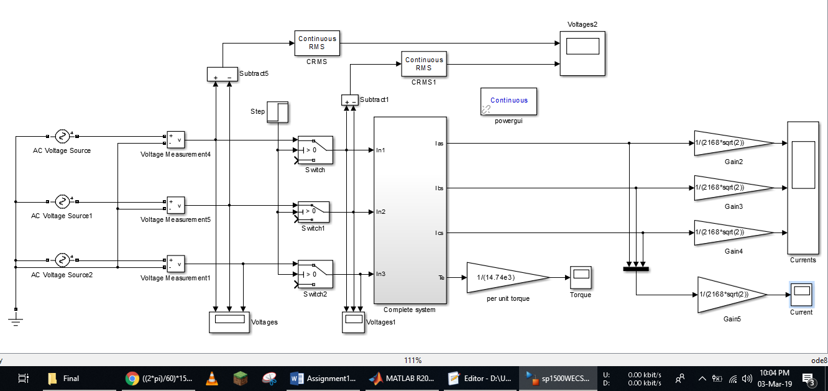

1. SCIG System

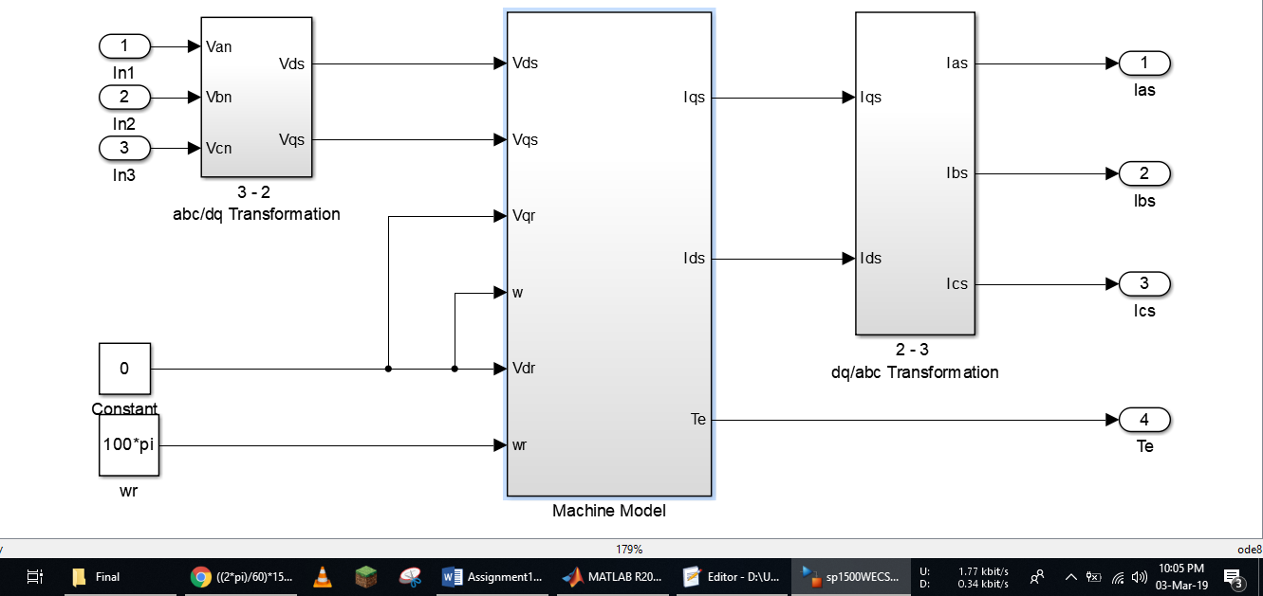

1. Block diagram for dynamic simulation of an induction generator in the arbitrary reference frame

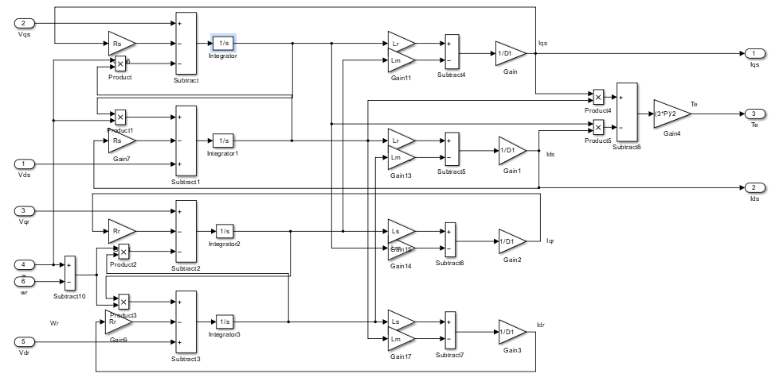

1. WECSConstants.m



Results

1. Currents

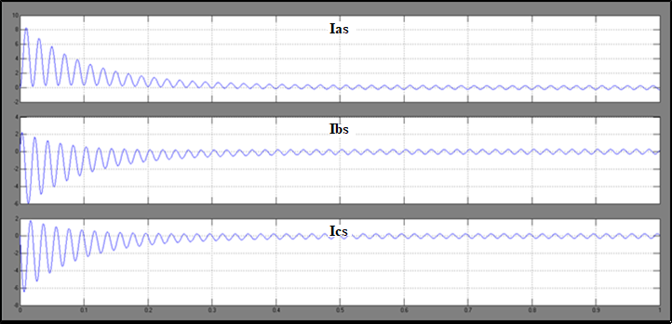

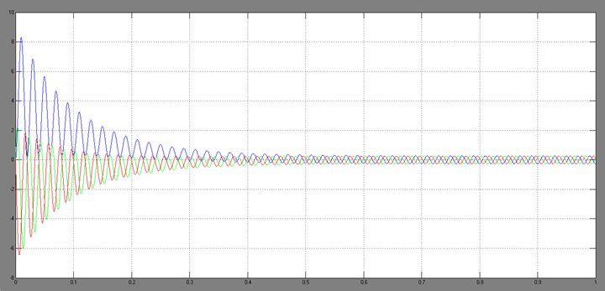

1. Electromagnetic Torque

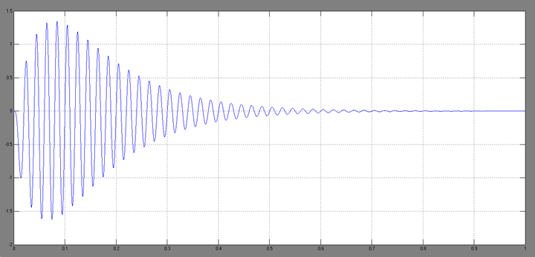

A high inrush current is drawn by the generator, with a peak value is 8.3 pu. The high amplitude of the stator currents causes oscillations in the generator torque Te with a peak of 1.63 pu. Compared with the previous case, the transient process is faster due to the constant rotor speed that eliminates the motion equation in the simulation. It can be concluded that the direct connection of a SCIG to the grid is not allowed in practice due to the excessive stator current and torque oscillations